LAB ACTIVITY 4
Name: Lorenzo M. Bautista Prof: Ma’am Gloria Dela Cruz
Section: BSIT 104 Date: May 15, 2026

Code:
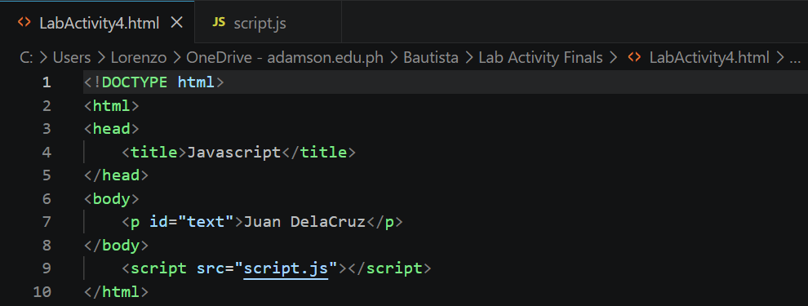
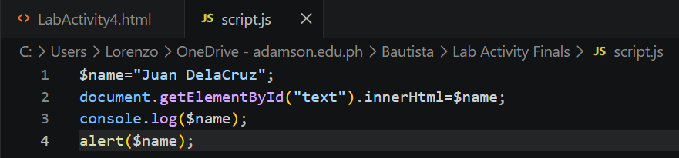
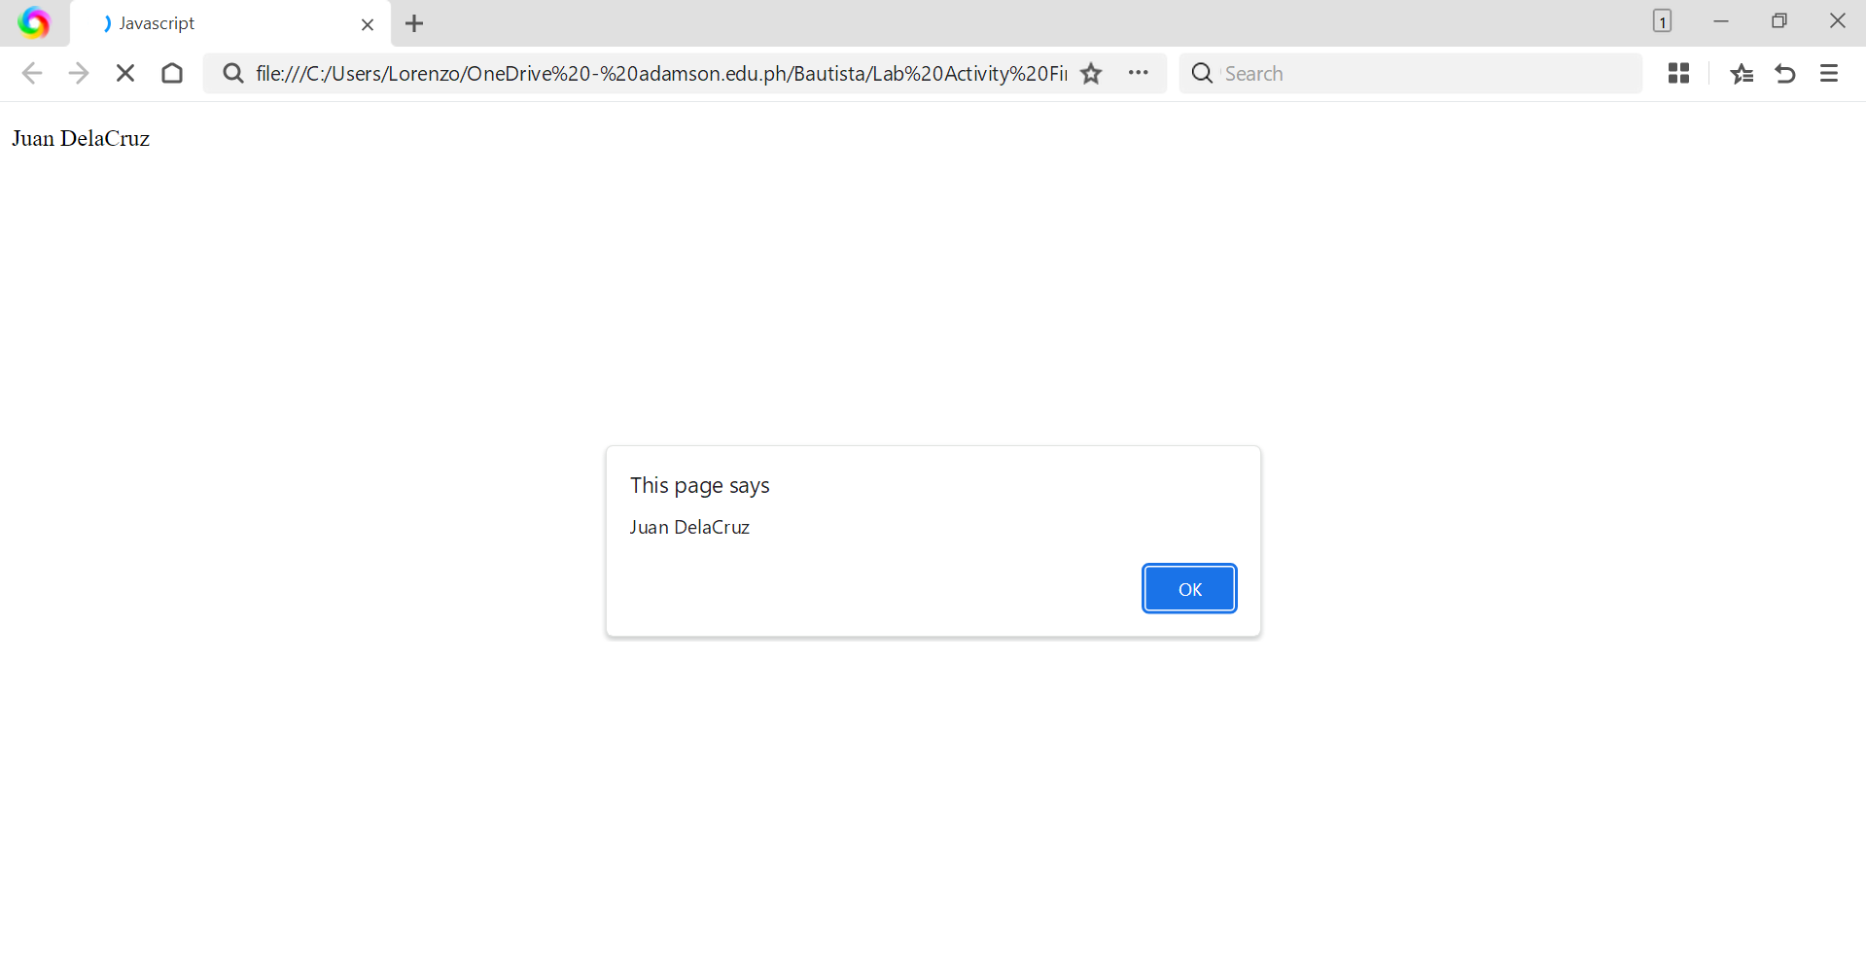
Output:

